**Final Report: GLP-1 Agonist Effect on Hypothalamic NPY/POMC Neurons**

BE 406: Bio Systems Engineering

Group 5: Adhav Narayanan

Alex Barletta

Alex Gennuso

Kira McLoughlin

Riley Wymer

May 4, 2025

**Introduction:** Glucagon-like peptide-1 receptor agonists (GLP-1RAs) are a class of drugs widely used to treat type 2 diabetes mellitus (T2DM) and, more recently, obesity. These agents mimic the gut hormone GLP-1, which promotes insulin secretion, slows gastric emptying, and increases satiety. In addition to their peripheral effects, GLP-1RAs also act on the hypothalamus, the brain region responsible for regulating appetite and energy balance. This action is particularly important given the strong link between obesity and type 2 diabetes and many individuals with T2DM struggle with weight gain and insulin resistance, both influenced by disrupted hypothalamic signaling. By targeting these neural circuits, GLP-1RAs offer a promising way to address both glycemic control and excess food intake. In this project, we model the effect of GLP-1 on hypothalamic regulation of appetite, examining how GLP-1 influences key neuronal populations such as POMC/CART and AgRP/NPY neurons, and other related pathways including α-MSH CRH, Ghrelin and GABA. Our model focuses solely on hypothalamic interactions, excluding downstream signaling in peripheral tissues, to better understand the specific effects of GLP-1.

**Methods:** We developed an ordinary differential equation (ODE)-based model to simulate the hypothalamic response to GLP-1 signaling (*Appendix B*)*.* Our framework tracks the transition between active and inactive states of each neuronal type, using kinetic equations to represent activation, inhibition, and decay processes (*Appendix A*)*.* To simplify the model, we assumed AgRP neurons are inhibited through uncompetitive binding with either α-MSH or GABA. All decay and deactivation followed first-order kinetics, with rate constants defined as k=ln⁡(2)/t, where t is the half-life. Additionally, neurons were treated as single compartments without spatial effects and parameter values were estimated using a mix of literature, inferred trends, and reasonable assumptions to ensure feasibility. This allowed us to simulate the hypothalamic effects of GLP-1 and track the balance between hunger and satiety signals over time.

**Key Results:** As seen in *Appendix D*, our model predicts that GLP-1 agonist stimulation leads to a rapid activation of POMC neurons, resulting in an early peak in α-MSH concentration and subsequent inhibition of AgRP neurons. This trend is clear in *Figure 6*, which assumed a GLP-1 concentration of 3M, where POMC activity (green) peaks around 2 hours, followed by a rise in α-MSH (light blue) and a decline in AgRP activity (red), supporting the role of GLP-1 in promoting satiety through the melanocortin pathway. Additionally, *Figure 7* shows that GABAergic inhibition of AgRP neurons builds more gradually, with GABA neurotransmitter release (GABAm) and its inhibitory effect (Inh2) peaking after α-MSH-mediated inhibition (Inh1). This sequential pattern, as seen in the top-right and bottom-center plots, suggests a two-phase suppression of AgRP activity, aligning with observations that GLP-1 exerts both fast and sustained anorexigenic effects through distinct hypothalamic pathways.

**Discussion:** Our model offers insight into how GLP-1 receptor agonists regulate satiety through hypothalamic pathways, emphasizing the sequential roles of POMC activation, α-MSH release, and AgRP inhibition. A key finding is the two-phase suppression of hunger signals: an early response via α-MSH and a sustained effect through delayed GABAergic inhibition of AgRP neurons. This dynamic may help explain the prolonged appetite-suppressing effects of GLP-1 therapies, even as drug levels decline. The model is limited in scope, focusing only on the hypothalamus and excluding downstream physiological effects such as insulin secretion or gastric emptying. It also omits signaling pathways like G-protein cascades, glutamate, and leptin which are not directly related to the hypothalamus, and includes parameter values that were partially inferred or assumed, introducing uncertainty. Despite these constraints, the model holds value for preclinical and clinical applications. By capturing the timing and strength of central satiety signals, it could be extended to simulate dose-response behavior or estimate EC50 like values. These insights may help guide drug optimization and dosing strategies for GLP-1 based therapies in obesity and type 2 diabetes.

# Appendix A – Figures & Graphs

**Figure 1:** Hypothalamic Regulation of Feeding Behavior

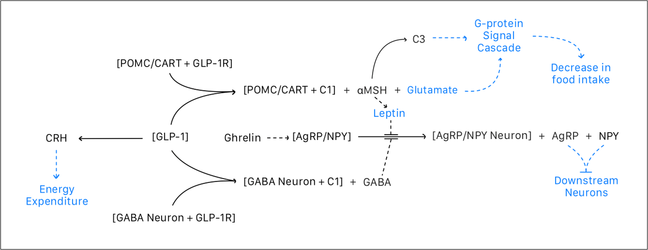

Simplified schematic of hypothalamic regulation of appetite. GLP-1 and leptin activate POMC/CART neurons while inhibiting AgRP/NPY neurons. POMC neurons release aMSH which binds MC4R and initiates a G-protein-coupled signaling cascade, ultimately decreasing food intake. Insulin plays a similar modulatory role. The downstream effect (i.e., reduced feeding) is depicted as the final behavior output of this regulatory circuit.

**Figure 2:** Combined Hypothalamic Model Behavior for 1M GLP-1 Concentration Assumption

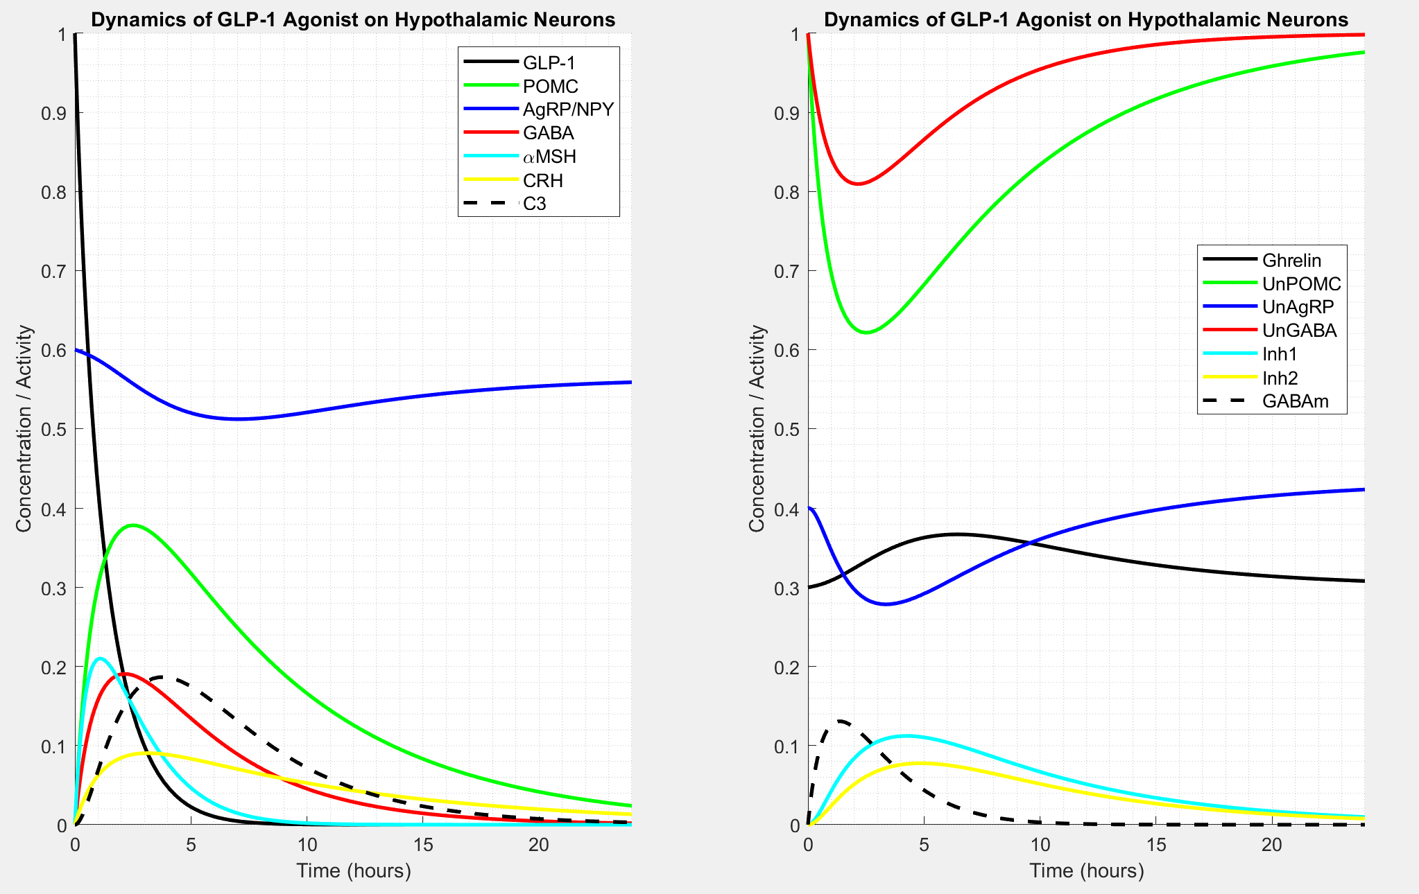

**Figure 3:** Individual Hypothalamic Model Behavior for 1M GLP-1 Concentration Assumption

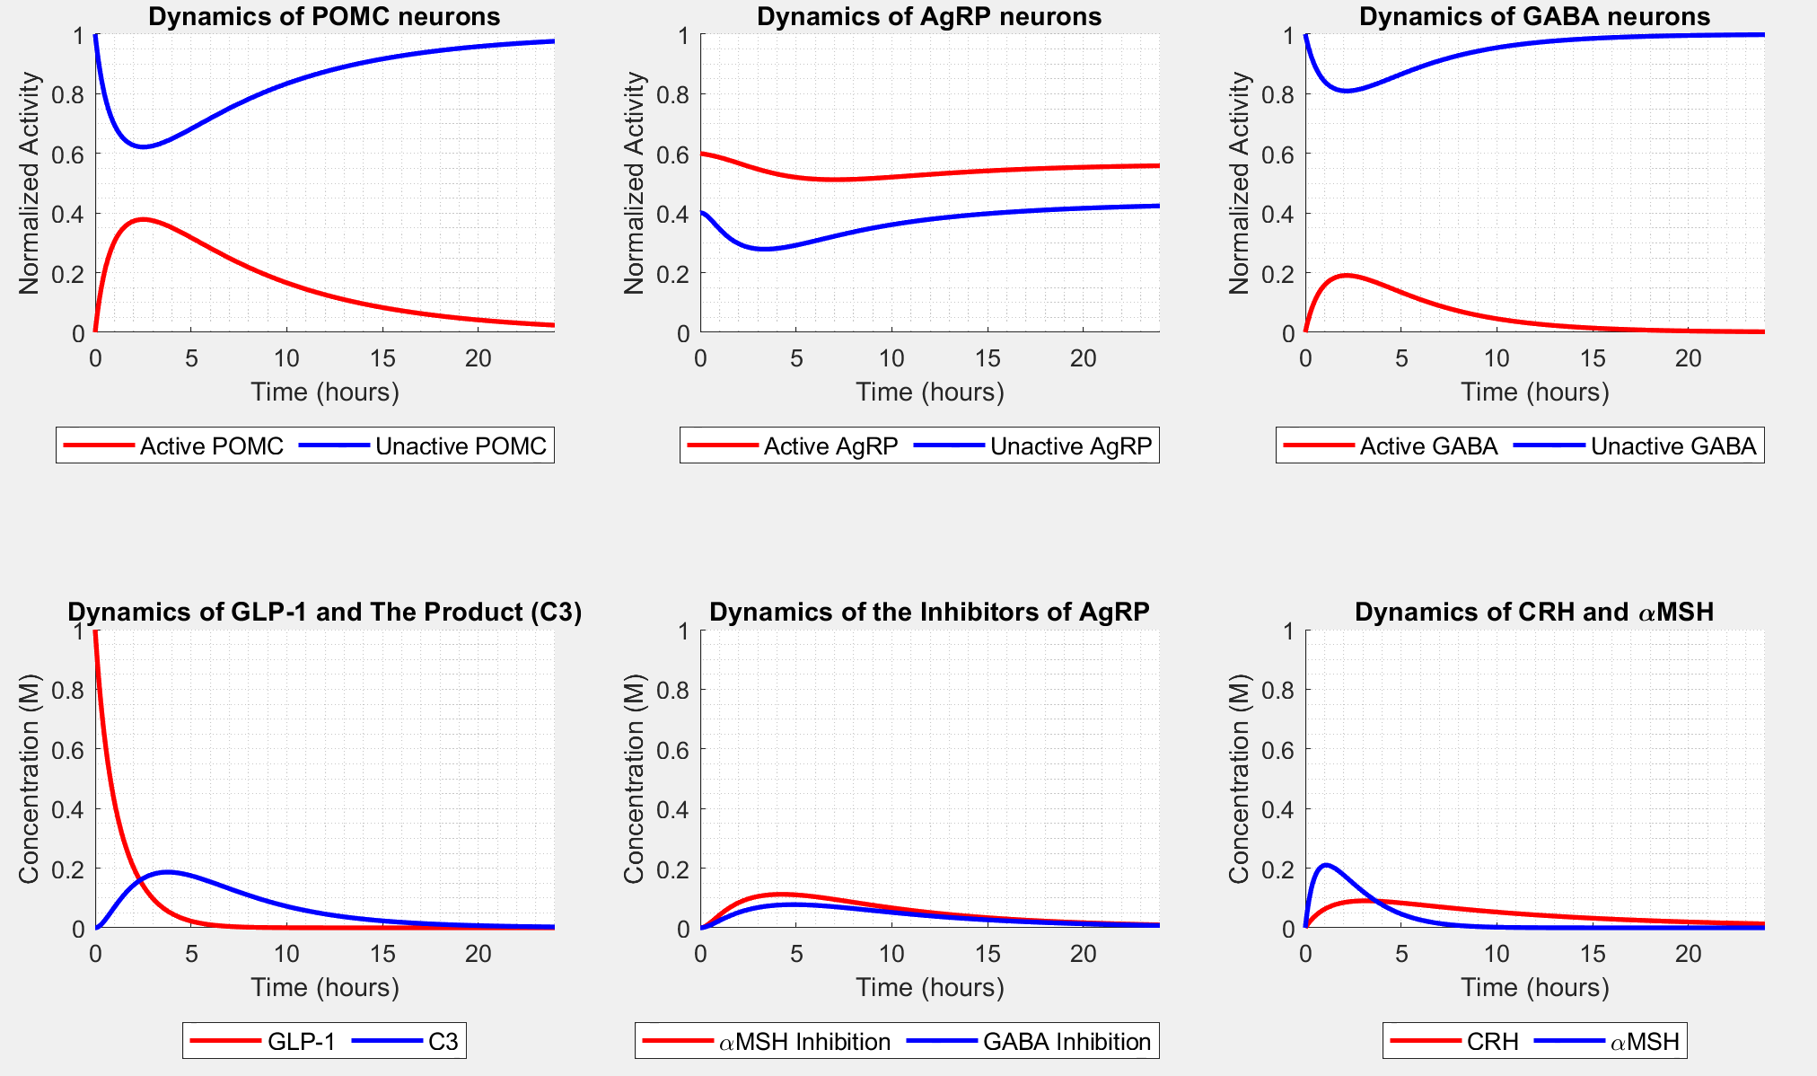

**Figure 4:** Combined Hypothalamic Model Behavior for 2M GLP-1 Concentration Assumption

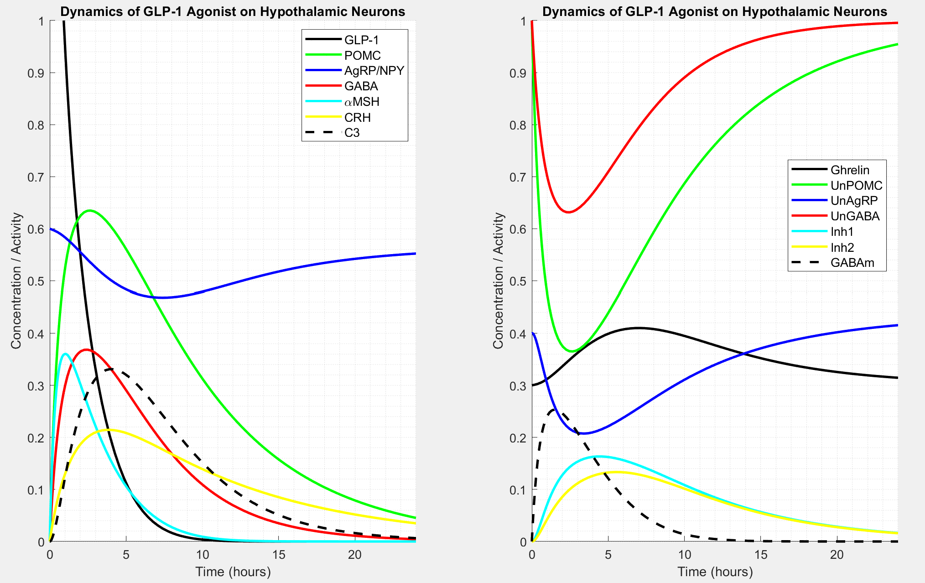

**Figure 5:** Individual Hypothalamic Model Behavior for 2M GLP-1 Concentration Assumption

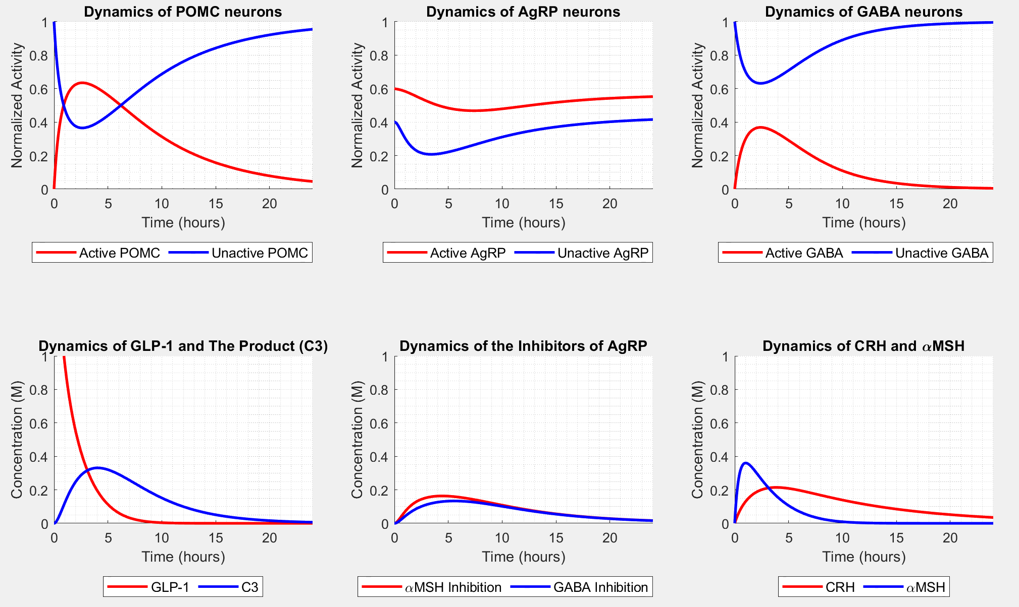

**Figure 6:** Combined Hypothalamic Model Behavior for 3M GLP-1 Concentration Assumption

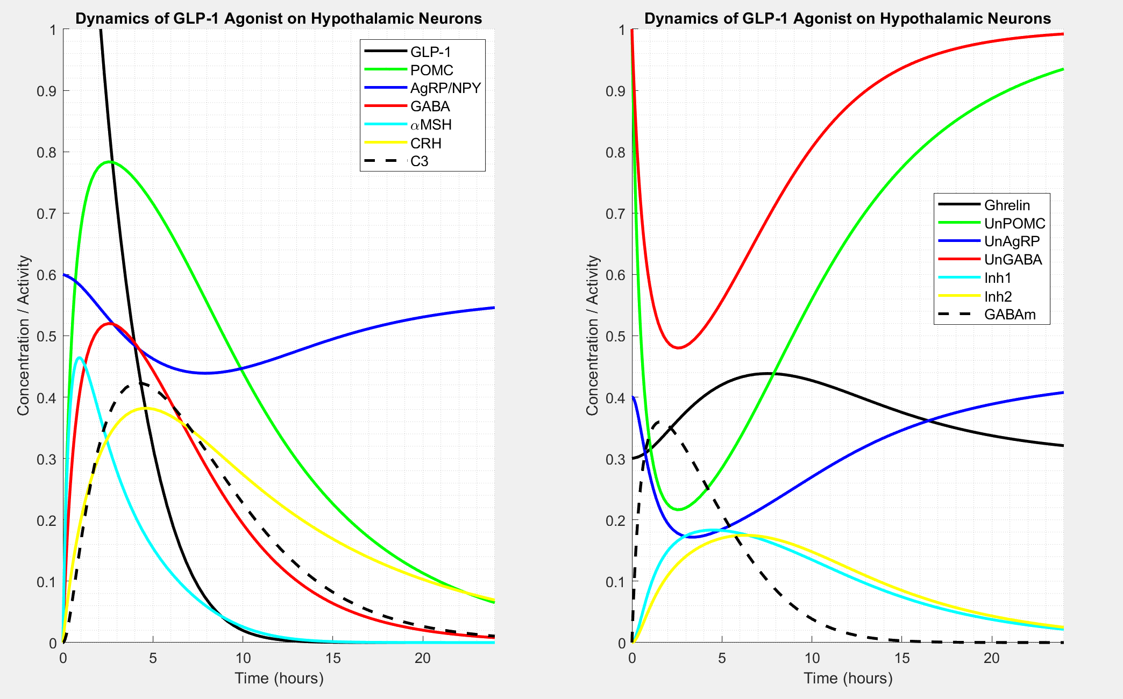

**Figure 7:** Individual Hypothalamic Model Behavior for 3M GLP-1 Concentration Assumption

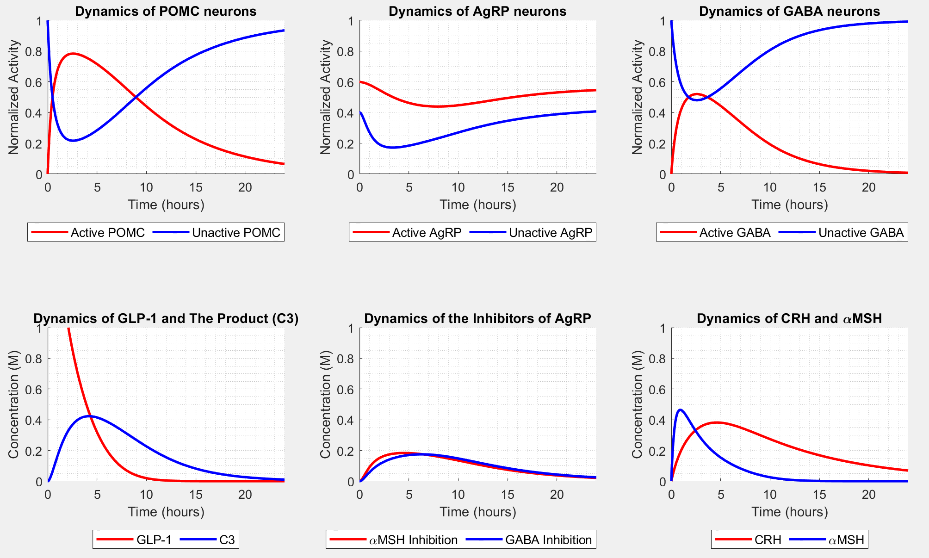

# Appendix B – Model Equations

**Table 1:** Key Definitions

|  |  |
| --- | --- |
| **Term** | **Definition** |
| GLP-1 | Glucose-Like Peptide-1 |
| AcPOMC / UnPOMC | Active/Unactive POMC neurons |
| AcAGRP / UnAGRP | Active/Unactive AgRP neurons |
| AcGABA / UnGABA | Active/Unactive neurons that emit GABA |
| CRH | Corticotrophin-Releasing Hormones |
| αMSH | Alpha-Melanocyte-Stimulating Hormones |
| GABAm | GABA Neurotransmitters |
| Inh1 | αMSH + UnAGRP, Uncompetitive Inhibition Complex |
| Inh2 | GABAm + UnAGRP, Uncompetitive Inhibition Complex |

**Figure 8:** Hypothalamic Regulation Differential Equations

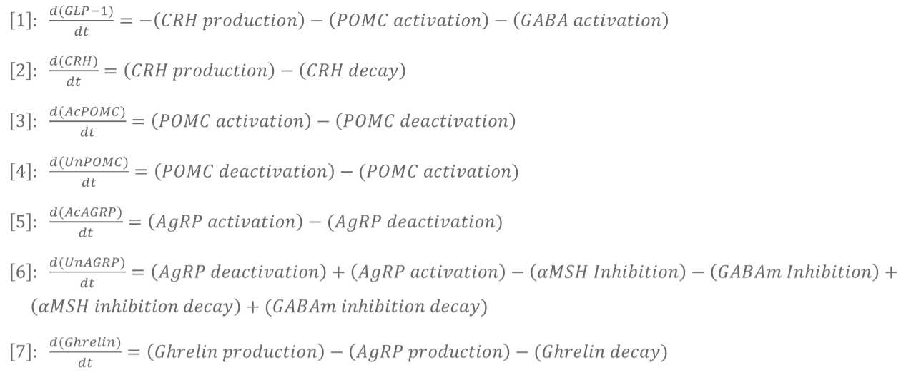 .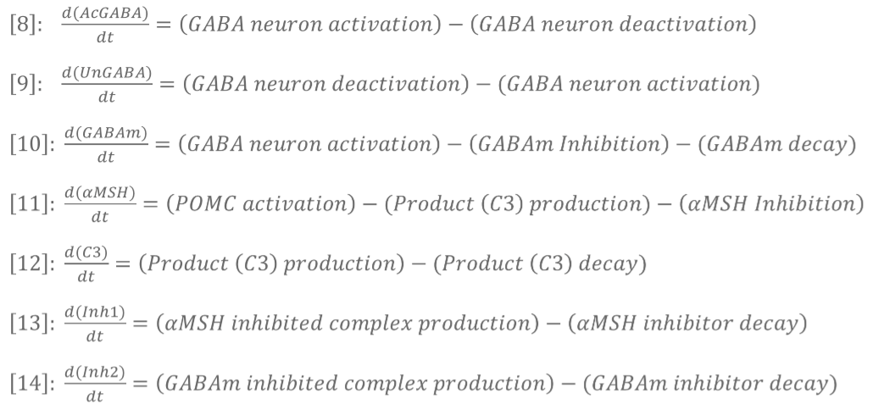

**Assumptions**

1. ΑMSH and GABAm uncompetitively inhibits the AgRP neuron

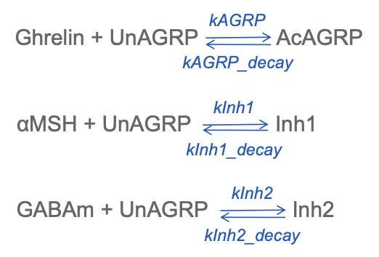

1. Both decaying and deactivation of neurons follows the equation

**Table 2:** Decay Parameter Values

|  |  |  |  |
| --- | --- | --- | --- |
| **Decay Parameter** | **Definition** | **Value** | **Citation** |
| kGLP1_decay | Rate of GLP-1 decaying (not used) |  | Hallare [6] |
| kCRH_decay | Rate of CRH decaying |  | Hallare [6] |
| kPOMC_decay | Rate of Active POMC inactivating |  | Hallare [6] |
| kAGRP_decay | Rate of Active AgRP inactivating |  | Hallare [6] |
| kGABA_decay | Rate of Active GABA inactivating |  | Hallare [6] |
| kInh1_decay | Rate of aMSH-AgRP inhibitor decaying |  | Hallare [6] |
| kInh2_decay | Rate of GABA-AgRP inhibitor decaying |  | Hallare [6] |
| kGABAm_decay | Rate of GABA decaying |  | Hallare [6] |
| kGhrelin_decay | Rate of Ghrelin decaying |  | Hallare [6] |
| kC3_decay | Rate of product (C3) decaying |  | Hallare [6] |

**Table 3:** Half Life Values

|  |  |  |  |
| --- | --- | --- | --- |
| **Decay Parameter** | **Definition** | **Value** | **Citation** |
| t_half_GLP1 | Half-life of GLP-1 decaying | 6 | Lee [15] |
| t_half_CRH | Half-life of CRH decaying | 7 | Nezi [18] |
| t_half_POMC | Half-life of Active POMC inactivating | 5 | Dong [5] |
| t_half_AGRP | Half-life of Active AgRP inactivating | 5 | Dong [5] |
| t_half_GABA | Half-life of Active GABA inactivating | 3 | Li [17] |
| t_half_Inh1 | Half-life of aMSH-AgRP inhibitor decaying | 5 | Lensing [16] |
| t_half_Inh2 | Half-life of GABA-AgRP inhibitor decaying | 5 | Lensing [16] |
| t_half_GABAm | Half-life of GABA decaying | 2 | Lensing [16] |
| t_half_Ghrelin | Half-life of Ghrelin decaying | 5 | Akamizu [2] |
| t_half_C3 | Half-life of product (C3) decaying | 3 | Ahn [1] |

**Table 4:** Rate Parameter Values

|  |  |  |  |
| --- | --- | --- | --- |
| **Rate Parameter** | **Definition** | **Value** | **Citation** |
| kGLP1 | Production rate of GLP1 (not used) | 0.8 | Cabou [3] |
| kCRH | Rate from GLP-1 to CRH | 0.1 | Larsen [16] |
| kPOMC | Rate from GLP-1 and Unactive POMC to Active POMC | 0.6 | Peterfi [20] |
| kAGRP | Rate from Ghrelin and Unactive AgRP to Active AgRP | 0.6 | De Solis [4] |
| kGABA | Rate from GLP-1 and Unactive GABA to Active GABA | 0.3 | Zheng [23] |
| kC3 | Rate from aMSH to the product (C3) | 0.5 | Heyder [9] |
| kInh1 | Rate from aMSH & Unactive AgRP to Inhibited AgRP (Inh1) | 0.8 | Zhang [22] |
| kInh2 | Rate from GABA & UNactive AgRP to Inhibited AgRP (Inh2) | 0.8 | Korgen [13] |
| kGhrelin | Production rate of Ghrelin | 0.12 | Ibrahim [10] |

**Table 5:** Initial Concentration Values

|  |  |  |  |
| --- | --- | --- | --- |
| **Initial Parameter** | **Definition** | **Value** | **Citation** |
| iGLP1 | Initial concentration of GLP1 | 1.0, 2.0, 3.0 | Assumed |
| iCRH | Initial concentration of CRH | ~ 0.0 | Edlow [5] |
| iAcPOMC | Initial concentration of Active POMC | ~ 0.0 | Harno [8] |
| iUnPOMC | Initial concentration of Unactive POMC | 1.0 | Harno [8] |
| iAcAGRP | Initial concentration of Active AgRP | 0.6 | Han [7] |
| iUnAGRP | Initial concentration of Unactive AgRP | 0.4 | Han [7] |
| iAcGABA | Initial concentration of Active GABA | ~ 0.0 | Jewett [11] |
| iUnGABA | Initial concentration of Unactive GABA | 1.0 | Jewett [11] |
| iGABAm | Initial concentration of GABAm | ~ 0.0 | Jewett [11] |
| iaMSH | Initial concentration of aMSH | ~ 0.0 | Turkkahraman [21] |
| iC3 | Initial concentration of product (C3) | ~ 0.0 | Oliveira [19] |
| iInh1 | Initial concentration of Inh1 | ~ 0.0 | Zhang [22] |
| iInh2 | Initial concentration of Inh2 | ~ 0.0 | Korgen [13] |
| iGhrelin | Initial concentration of Ghrelin | 0.3 | Khono [12] |

# Appendix C – MATLAB Code

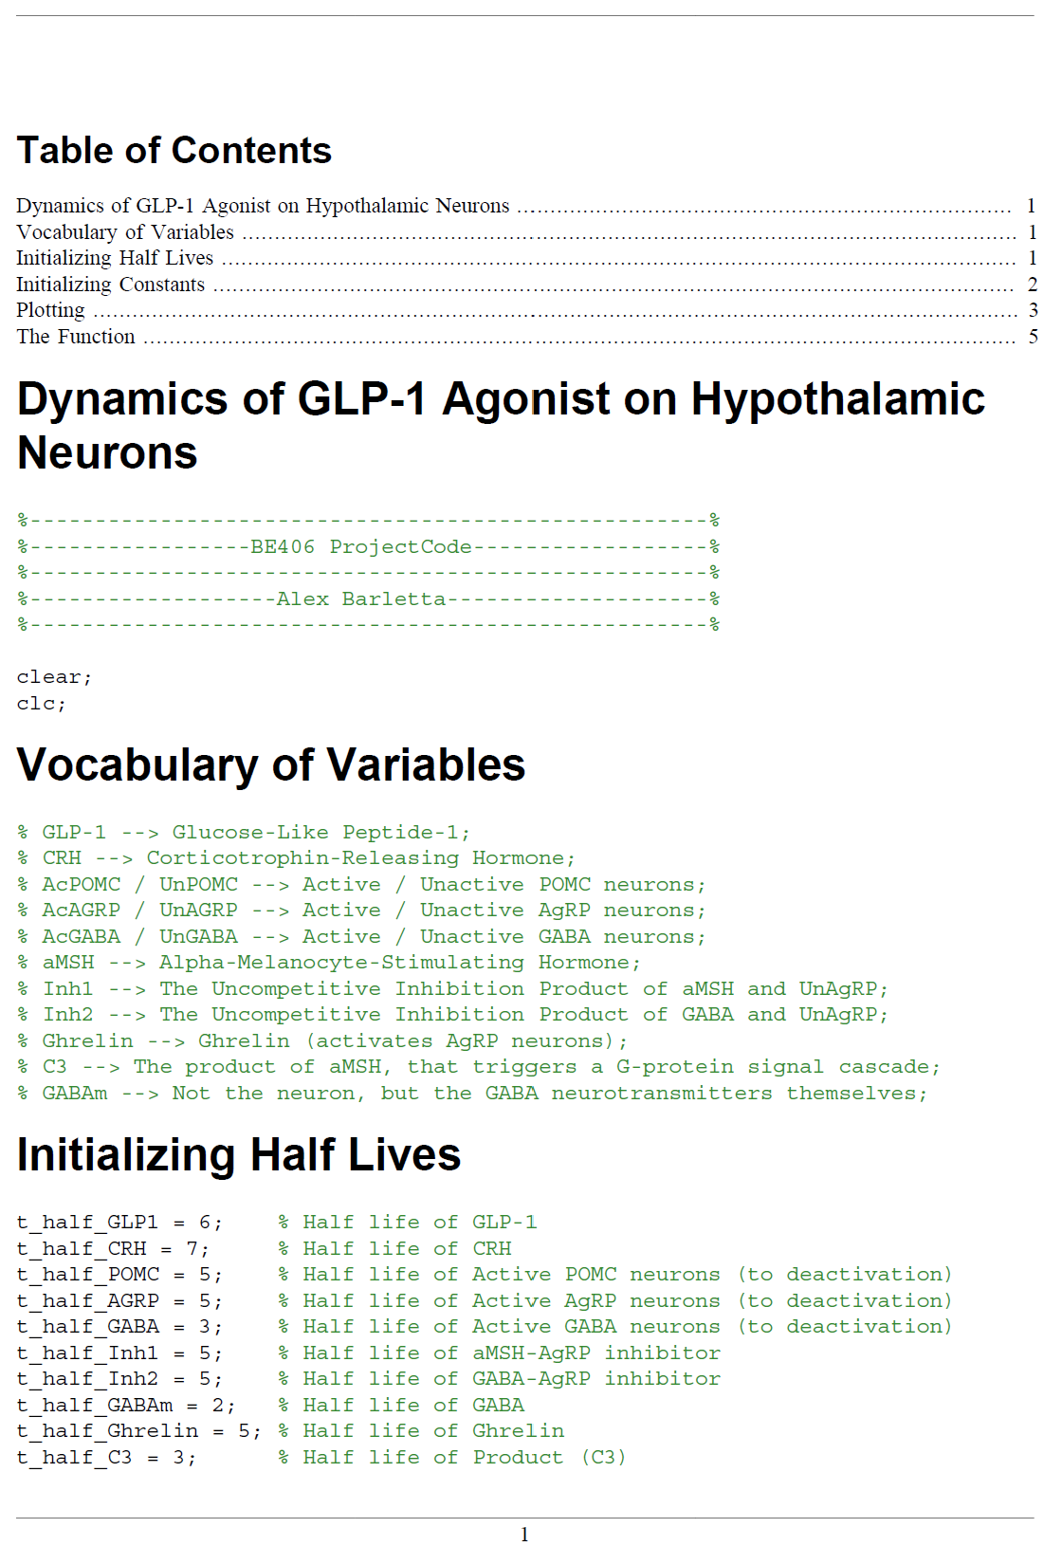

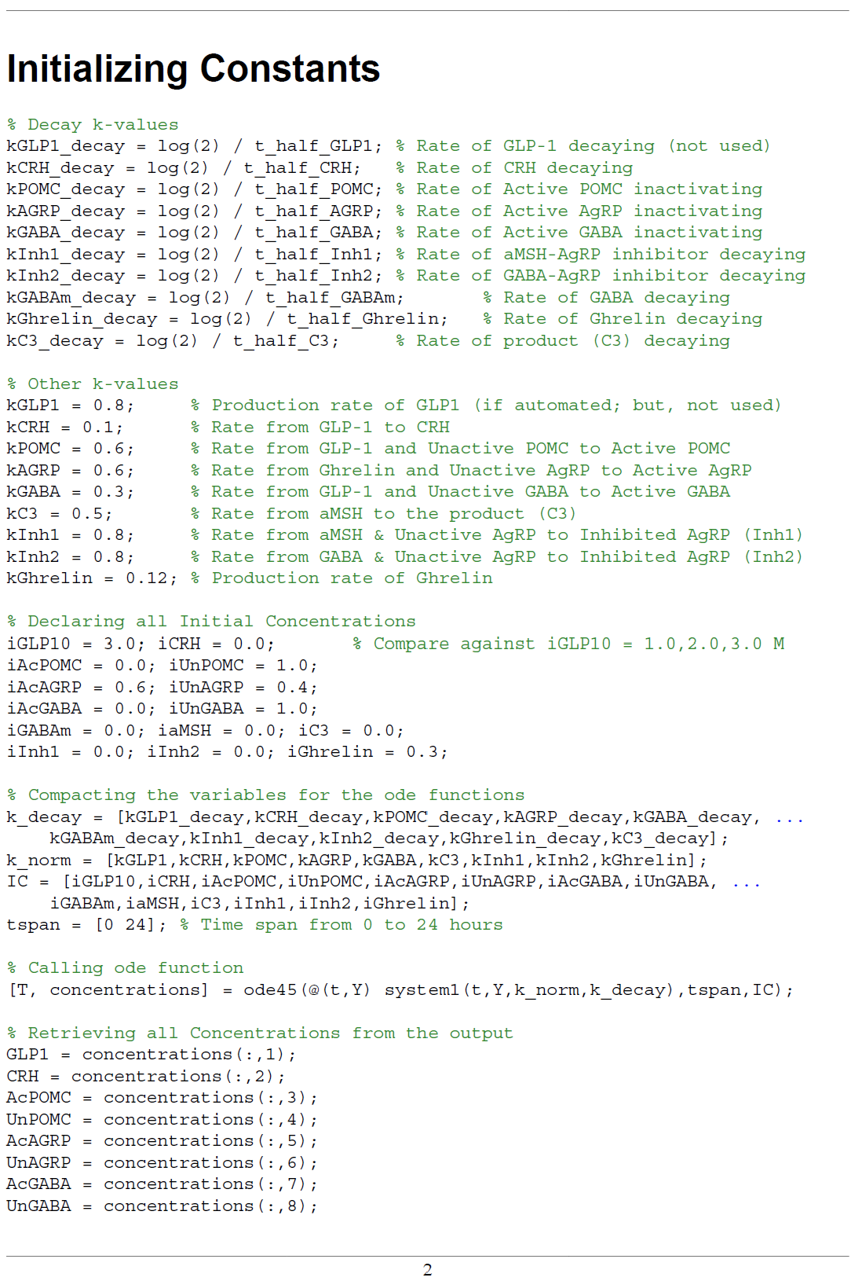

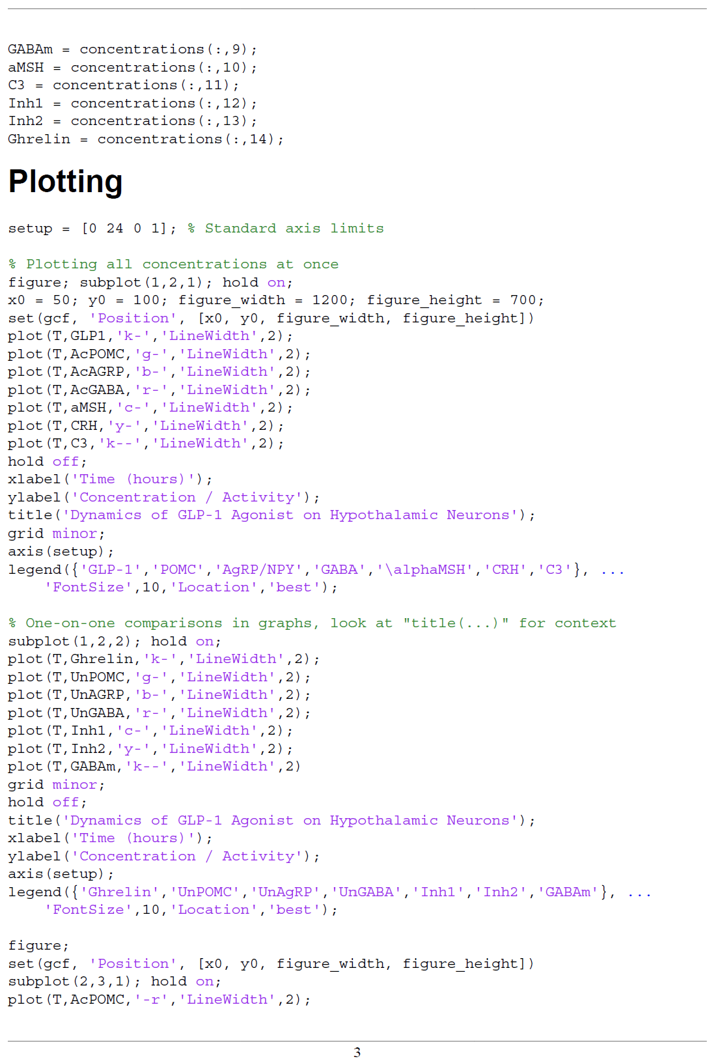

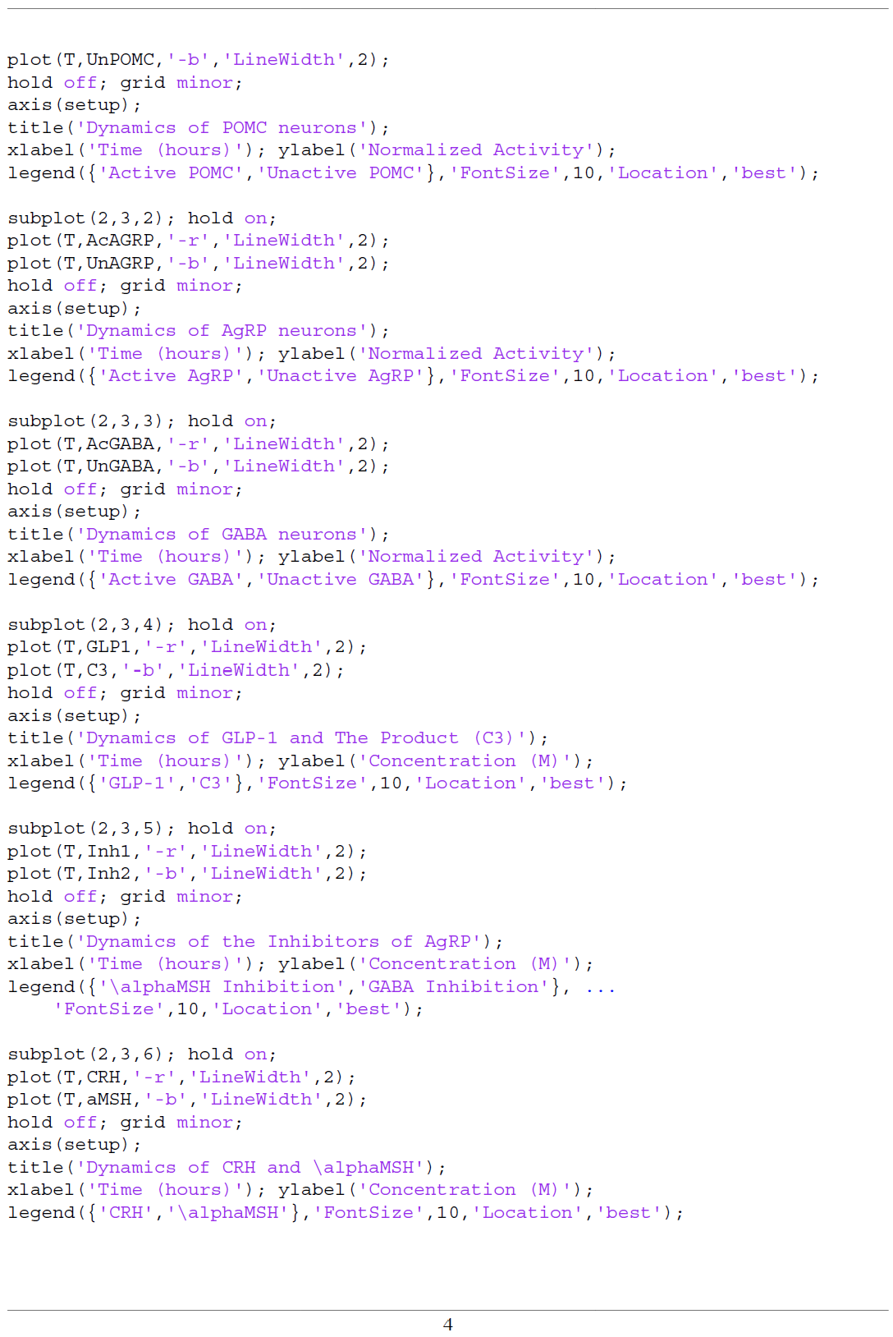

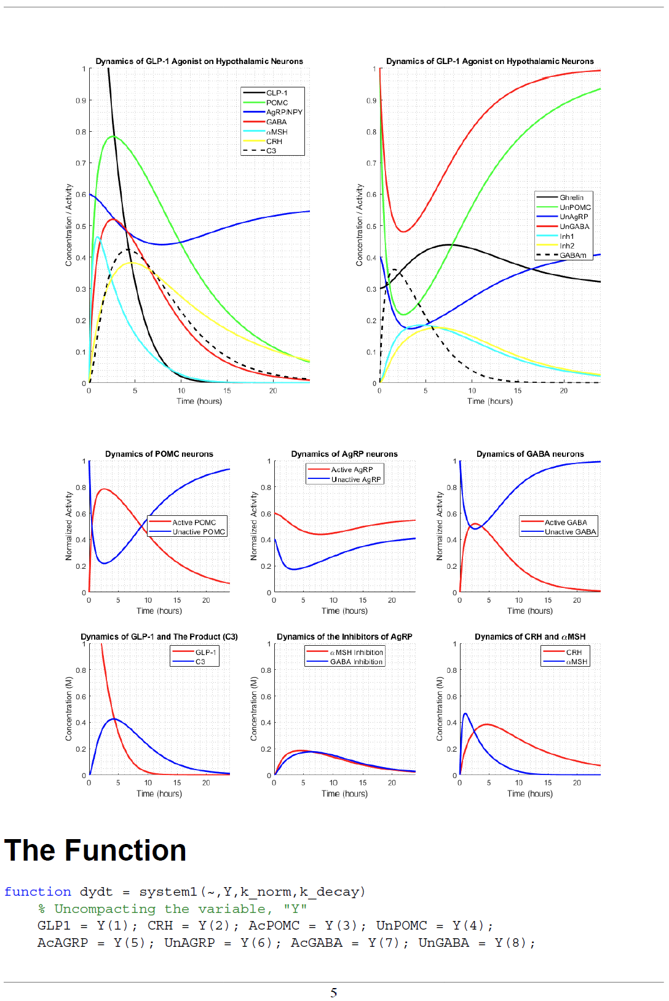

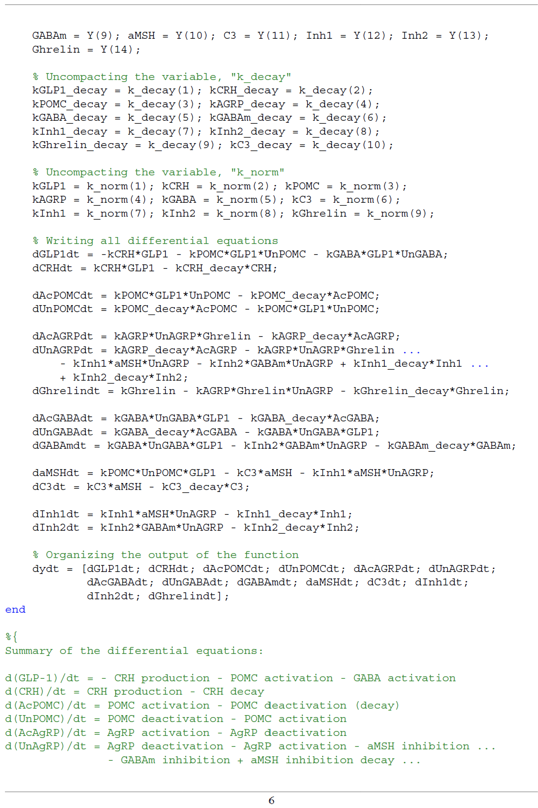



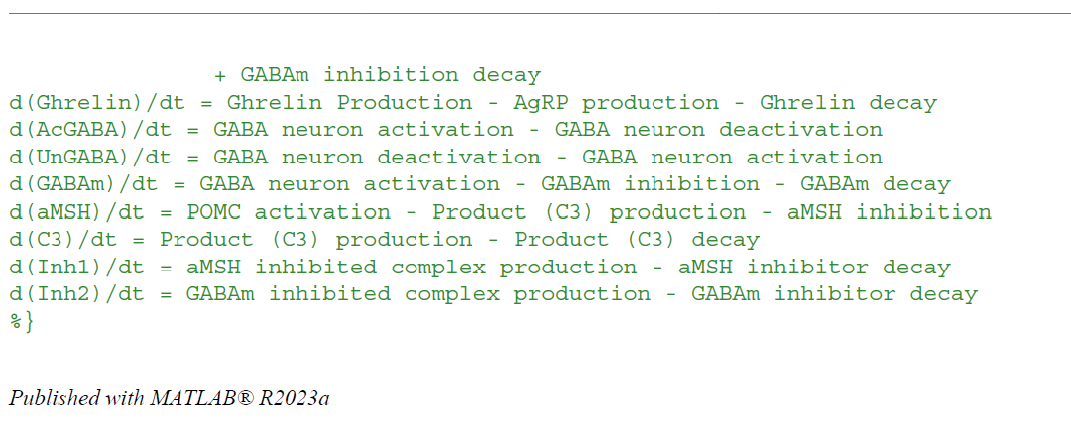

# Appendix D – Parameter Table

**Table 6:** Full Parameter Table

|  |  |  |  |  |
| --- | --- | --- | --- | --- |
| **Parameter** | **Value** | **Unit** | **Justification** | **Citation** |
| kGLP1_decay | 0.051 | 1/hr | Initial injection must decay | Hallare [6] |
| kCRH_decay | 0.043 | 1/hr | Hormone signals are terminated | Hallare [6] |
| kPOMC_decay | 0.060 | 1/hr | Neurons inactivate | Hallare [6] |
| kAGRP_decay | 0.060 | 1/hr | Neurons inactivate | Hallare [6] |
| kGABA_decay | 0.100 | 1/hr | Neurotransmitters inactivate | Hallare [6] |
| kInh1_decay | 0.060 | 1/hr | Inhibitors inactivate | Hallare [6] |
| kInh2_decay | 0.060 | 1/hr | Inhibitors inactivate | Hallare [6] |
| kGABAm_decay | 0.151 | 1/hr | Neurotransmitters are removed | Hallare [6] |
| kGhrelin_decay | 0.060 | 1/hr | Hormone signals are terminated | Hallare [6] |
| kC3_decay | 0.100 | 1/hr | Product decays | Hallare [6] |
| t_half_GLP1 | 6 | hr | Injection has a half-life | Lee [15] |
| t_half_CRH | 7 | hr | Signal has a half-life | Nezi [18] |
| t_half_POMC | 5 | hr | Activation has a half-life | Dong [5] |
| t_half_AGRP | 5 | hr | Activation has a half-life | Dong [5] |
| t_half_GABA | 3 | hr | Activation has a half-life | Li [17] |
| t_half_Inh1 | 5 | hr | Inhibition has a half-life | Lensing [16] |
| t_half_Inh2 | 5 | hr | Inhibition has a half-life | Lensing [16] |
| t_half_GABAm | 2 | hr | Signal has a half-life | Lensing [16] |
| t_half_Ghrelin | 5 | hr | Signal has a half-life | Akamizu [2] |
| t_half_C3 | 3 | hr | Product has a half-life | Ahn [1] |
| kGLP1 | 0.8 | 1/hr | GLPR-1 rate of production | Cabou [3] |
| kCRH | 0.1 | 1/hr | GLP-1 to CRH rate | Larsen [16] |
| kPOMC | 0.6 | 1/hr | GLP-1 and Unactive POMC to Active POMC rate | Peterfi [20] |
| kAGRP | 0.6 | 1/hr | Ghrelin and Unactive AgRP to Active AgRP rate | De Solis [4] |
| kGABA | 0.3 | 1/hr | GLP-1 and Unactive GABA to Active GABA rate | Zheng [23] |
| kC3 | 0.5 | 1/hr | aMSH to the product (C3) rate | Heyder [9] |
| kInh1 | 0.8 | 1/hr | aMSH & Unactive AgRP to Inhibited AgRP (Inh1) rate | Zhang [22] |
| kInh2 | 0.8 | 1/hr | GABA & UNactive AgRP to Inhibited AgRP (Inh2) rate | Korgen [13] |
| kGhrelin | 0.12 | 1/hr | Ghrelin rate of production | Ibrahim [10] |
| iGLP1 | 1.0, 2.0, 3.0 | M | Initial concentration of GLP1 | Assumed |
| iCRH | 0.0 | M | Initial concentration of CRH | Edlow [5] |
| iAcPOMC | 0.0 | M | Initial concentration of Active POMC | Harno [8] |
| iUnPOMC | 1.0 | M | Initial concentration of Unactive POMC | Harno [8] |
| iAcAGRP | 0.6 | M | Initial concentration of Active AgRP | Han [7] |
| iUnAGRP | 0.4 | M | Initial concentration of Unactive AgRP | Han [7] |
| iAcGABA | 0.0 | M | Initial concentration of Active GABA | Jewett [11] |
| iUnGABA | 1.0 | M | Initial concentration of Unactive GABA | Jewett [11] |
| iGABAm | 0.0 | M | Initial concentration of GABAm | Jewett [11] |
| iaMSH | 0.0 | M | Initial concentration of aMSH | Turkkahraman [21] |
| iC3 | 0.0 | M | Initial concentration of product (C3) | Oliveira [19] |
| iInh1 | 0.0 | M | Initial concentration of Inh1 | Zhang [22] |
| iInh2 | 0.0 | M | Initial concentration of Inh2 | Korgen [13] |
| iGhrelin | 0.3 | M | Initial concentration of Ghrelin | Khono [12] |

# Appendix E – References

[1] Ahn, D. (2023, April 8). Gαs slow conformational transition upon GTP binding and a novel Gαs

Regulator. IScience. <https://www.sciencedirect.com/science/article/pii/S2589004223006806#:~:text=The%20half%2Dlife%20of%20state,shown%20in%20Figure%202C>

[2] Akamizu T;Takaya K;Irako T;Hosoda H;Teramukai S;Matsuyama A;Tada H;Miura K;Shimizu

A;Fukushima M;Yokode M;Tanaka K;Kangawa K; (n.d.). Pharmacokinetics, safety, and endocrine and appetite effects of ghrelin administration in Young Healthy Subjects. European journal of endocrinology. <https://pubmed.ncbi.nlm.nih.gov/15080773/>

[3] Cabou, C., & Burcelin, R. (2011). GLP-1, the gut-brain, and brain-periphery axes. The review of

diabetic studies : RDS. <https://pmc.ncbi.nlm.nih.gov/articles/PMC3280675/>

[4] De Solis, A. J., Del Río-Martín, A., Radermacher, J., Chen, W., Steuernagel, L., Bauder, C. A.,

Eggersmann, F. R., Morgan, D. A., Cremer, A.-L., Sué, M., Germer, M., Kukat, C., Vollmar, S., Backes, H., Rahmouni, K., Kloppenburg, P., & Brüning, J. C. (2024, February 20). Reciprocal activity of AgRP and POMC neurons governs coordinated control of feeding and metabolism. Nature News. <https://www.nature.com/articles/s42255-024-00987-z>

[5] Dong, Y., Carty, J., Goldstein, N., He, Z., Hwang, E., Chau, D., Wallace, B., Kabahizi, A., Lieu, L.,

Peng, Y., Gao, Y., Hu, L., Betley, J. N., & Williams, K. W. (2021, December). Time and metabolic state-dependent effects of GLP-1R agonists on NPY/AGRP and POMC neuronal activity in vivo. Molecular metabolism. <https://pmc.ncbi.nlm.nih.gov/articles/PMC8590079/>

[5] Edlow, A. (n.d.). Corticotropin Blood Level. Corticotropin Blood Level - an overview | ScienceDirect

Topics. <https://www.sciencedirect.com/topics/biochemistry-genetics-and-molecular-biology/corticotropin-blood-level>

[6] Hallare, J. (2023, June 20). Half life. StatPearls [Internet].

<https://www.ncbi.nlm.nih.gov/books/NBK554498/>

[7] Han, J., Liang, X., Guo, Y., Wu, X., Li, Z., & Hong, T. (2025, May 4). Agouti-related protein as the

glucose signaling sensor in the central melanocortin circuits in regulating fish food intake. Frontiers. <https://www.frontiersin.org/journals/endocrinology/articles/10.3389/fendo.2022.1010472/full>

[8] Harno, E. (n.d.). POMC: The physiological power of hormone processing | physiological reviews |

american physiological society. America Physiological Society. <https://journals.physiology.org/doi/full/10.1152/physrev.00024.2017>

[9] Heyder, N., Kleinau, G., Szczepek, M., Kwiatkowski, D., Speck, D., Soletto, L., Cerd&aacute;

Reverter, J. M., Krude, H., K&uuml;hnen, P., Biebermann, H., & Scheerer, P. (2025, May 4). Signal transduction and pathogenic modifications at the melanocortin-4 receptor: A structural perspective. Frontiers. <https://www.frontiersin.org/journals/endocrinology/articles/10.3389/fendo.2019.00515/full>

[10] Ibrahim, A, M. M. (2015, August). Ghrelin - physiological functions and regulation. European

endocrinology. <https://pmc.ncbi.nlm.nih.gov/articles/PMC5819073/>

[11] Jewett, B. E. (2023, July 24). Physiology, GABA. StatPearls [Internet].

<https://www.ncbi.nlm.nih.gov/books/NBK513311/>

[12] Kohno, D. (n.d.). Ghrelin directly interacts with neuropeptide-y-containing neurons in the rat arcuate

nucleus | diabetes | american diabetes association. American Diabetes Association. <https://diabetesjournals.org/diabetes/article/52/4/948/11107/Ghrelin-Directly-Interacts-With-Neuropeptide-Y>

[13] Korgan, A. C., Wei, W., Martin, S. L. A., Kaczorowski, C. C., & O’Connell, K. M. S. (2021,

January 1). High-fat diet induced loss of GABAergic inhibition decouples intrinsic and synaptic excitability in AgRP neurons. bioRxiv. <https://www.biorxiv.org/content/10.1101/2021.05.31.446473v1.full>

[14] Larsen, P. (n.d.). Central Administration of Glucagon-Like Peptide-1 Activates Hypothalamic

Neuroendocrine Neurons in the Rat. Oxford University Press. <https://academic.oup.com/endo/article-abstract/138/10/4445/2988189?redirectedFrom=fulltext>

[15] Lee, S., & Lee, D. Y. (2017, March). Glucagon-like peptide-1 and glucagon-like peptide-1 receptor

agonists in the treatment of type 2 diabetes. Annals of pediatric endocrinology & metabolism. <https://pmc.ncbi.nlm.nih.gov/articles/PMC5401818/#:~:text=Native%20GLP%2D1%20has%20a,endopeptidase%20(NEP)68>

[16] Lensing, C. J., Adank, D. N., Wilber, S. L., Freeman, K. T., Schnell, S. M., Speth, R. C., Zarth, A.

T., & Haskell-Luevano, C. (2017, June 21). A direct in vivo comparison of the melanocortin monovalent agonist AC-his-dphe-ARG-trp-NH2 versus the bivalent agonist ac-his-dphe-arg-trp-pedg20-his-dphe-arg-trp-NH2: A bivalent advantage. ACS chemical neuroscience. <https://pmc.ncbi.nlm.nih.gov/articles/PMC5679024/>

[17] Li, J., Zhang, Z., Liu, X., Wang, Y., Mao, F., Mao, J., Lu, X., Jiang, D., Wan, Y., Lv, J.-Y., Cao, G.,

Zhang, J., Zhao, N., Atkinson, M., Greiner, D. L., Prud’homme, G. J., Jiao, Z., Li, Y., & Wang, Q. (2015, November 10). Study of GABA in healthy volunteers: Pharmacokinetics and Pharmacodynamics. Frontiers in pharmacology. <https://pmc.ncbi.nlm.nih.gov/articles/PMC4639630/>

[18] Nezi, M. (2015, July 30). Corticotropin releasing hormone and the immune/inflammatory response.

Endotext [Internet]. <https://www.ncbi.nlm.nih.gov/books/NBK279017/>

[19] Oliveira, P. G. de, Ramos, M. L. S., Amaro, A. J., Dias, R. A., & Vieira, S. I. (2025, May 4). GI/O

protein coupled receptors in the aging brain. Frontiers. <https://www.frontiersin.org/journals/aging-neuroscience/articles/10.3389/fnagi.2019.00089/full>

[20] Peterfi, Z. (n.d.). Glucagon-Like Peptide-1 Regulates the Proopiomelanocortin Neurons of the

Arcuate Nucleus both Directly and Indirectly via Presynaptic Action. Karger. <https://karger.com/nen/article/111/10/986/825306/Glucagon-Like-Peptide-1-Regulates-the>

[21] Turkkahraman, D. (n.d.). Serum alpha-melanocyte-stimulating hormone (a-MSH), brain-derived

neurotrophic factor (BDNF), and agouti-related protein (AGRP) levels in children with prader-willi or Bardet-Biedl syndromes. Journal of endocrinological investigation. <https://pubmed.ncbi.nlm.nih.gov/35098494/>

[22] Zhang, J., Li, X., Zhou, Y., Cui, L., Li, J., Wu, C., Wan, Y., Li, J., & Wang, Y. (2017, August 1).

The interaction of MC3R and MC4R with MRAP2, ACTH, α-MSH and AgRP in chickens. joe. <https://joe.bioscientifica.com/view/journals/joe/234/2/JOE-17-0131.xml>

[23] Zheng, Z., Zong, Y., Ma, Y., Tian, Y., Pang, Y., Zhang, C., & Gao, J. (2024, September 18).

Glucagon-like peptide-1 receptor: Mechanisms and advances in therapy. Nature News. <https://www.nature.com/articles/s41392-024-01931-z>

# Appendix F – Team Contributions

1. Adhav Narayanan
2. Alex Barletta
3. Alex Gennuso
4. Kira McLoughlin
5. Riley Wymer

All team members contributed equally.